**CUSTOMER CHURN ANALYSIS**

### **BANK CUSTOMER DATA**

**Overview**

What is Customer churn? This is essentially the rate at which customers leave a business against the total customers that are actively in business. This is also known as churn rate or customer attrition.

**Project Objective:**

The objective of this analysis is to discover various factors contributing to increased customer churn rate at the bank, and provide the business users with these insights which they can use to make informed decisions and strategize on how to improve customer retention and reduce churn rate.

Tools: I used Power BI and Power Query for this analysis.

**Dataset Description**

The raw data was provided in the form of a CSV file with 10,000 rows of data. Data was sourced from a commercial bank who was looking to improve its customer churn rate.

Note: all personally Identifiable information has been removed from this data to protect customer’s private and sensitive information.

Data Dictionary

• customer_id: This is the customers’ unique id which identifies them bankwide.

• credit_score: this is the rating of the customers’ credit worthiness, generated based on the information on their credit report.

• country: This is the country the customer hails from.

• gender: This is the sex of the customer, grouped into male and female.

• age: This refers to the customer’s age.

• tenure: The number of years of relationship this customer has maintained with the bank.

• balance: The deductible balance on their bank account as at time this data was generated.

• products_number: This shows the bank account type the customer has.

• credit_card: This column shows if a customer has a credit card or not, represented as either 1 or 0 respectively.

• active_member: These numerical values show whether an account is active or not, represented as either 1 or 0 respectively.

• estimated_ salary: This is the average annual salary received into the account

.• churn: This field shows if the customer is still with the bank or not, represented by either 0 or 1 respectively.

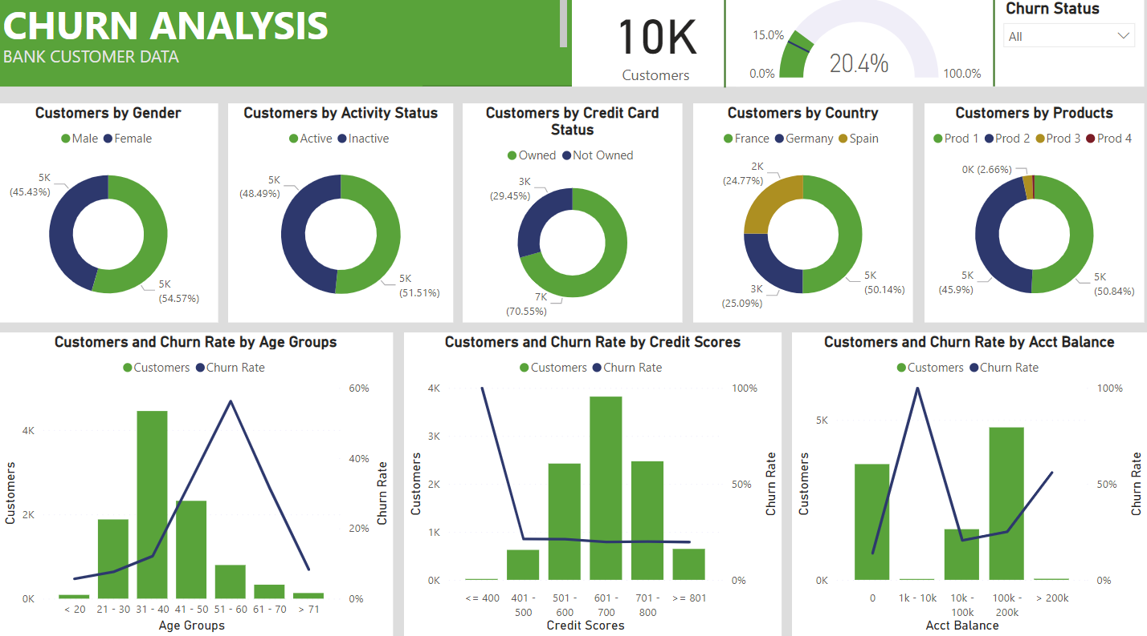

**Insights**

* Churn rate for male customers is 65% but the overall male churn rate is at 25%.
* In terms of those with credit card facility, the churn rate is highest amongst lowest credit score group of >400
* Surprisingly, the customers whose account balance are <=200k are the most churned in terms of account balance.
* Overall, Churn rate is very high at 56.2% for middle aged customers between 51–60 years of age.

For the products, churn rate is high @ 27.7% amongst customers in the Prod 1 group. The age account and credit score factors are same here. Similar situation for prod 2 =, however in prod 2, the churn rate is at all time 100% for customers between the 1k-1ok account balance.

**Recommendations**

* Products: Create products targeting seniors approaching retirement age.
* Incentive Programs: Implement incentives for long-term customers.
* Exclusive Packages: Offer exclusive packages for customers with high account balances (>200k).
* Investigate Product Performance: Investigate reasons behind 100% churn rate for specific product groups.

In Summary, age group of 51–60, people with low credit scores and those with high account balance (>200k) are most likely to churn. The bank should consider the recommendations above and other effective strategies that can address the findings, to better customer retention and reduce chrun rate.

Important links:

https://github.com/GreeshmaGundapaneni/Customer-Churn-Analysis